Tool Guide – Fcrackzip

Introduction
Fcrackzip is a password-cracking tool used to recover passwords from encrypted ZIP archives using brute-force or dictionary attacks. It is especially useful in the Password Cracking and Authentication Testing phase of ethical hacking to demonstrate weaknesses in ZIP-based encryption.
Safety Disclaimer: Only use Fcrackzip on ZIP files that you own or have explicit permission to test. Unauthorized access or password cracking is illegal and unethical.

Setup and Launch
Step 1: Open Deakin Detonator Toolkit
- Launch Terminal in your Kali Linux or other supported Linux environment.
- Navigate to the directory where the Deakin Detonator Toolkit is located:
  - cd ~/Deakin-Detonator-Toolkit
- Start the toolkit using the command:
  - yarn run tauri dev

  - 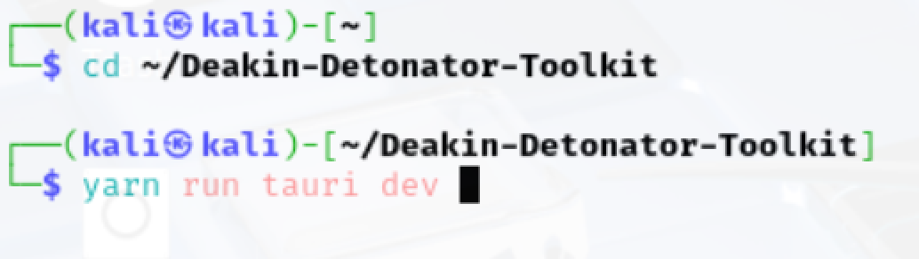
- This will launch the main interface of the toolkit.
Step 2: Locate the Tool
- Click on “Tools” from the left-hand side menu or use the search bar.

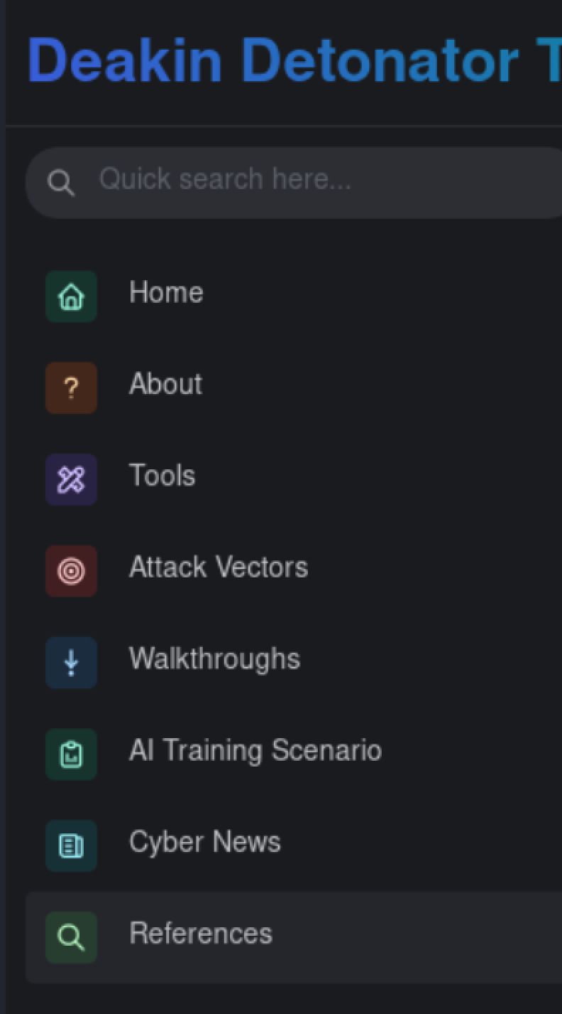

- Locate Fcrackzip from the Password Cracking and Authentication Testing section and click the Go button.

Step 3: Install Required Component
When launching Fcrackzip for the first time, you may be prompted to install missing dependencies.
- Click Install Component when prompted.
- You’ll be asked for superuser authentication.

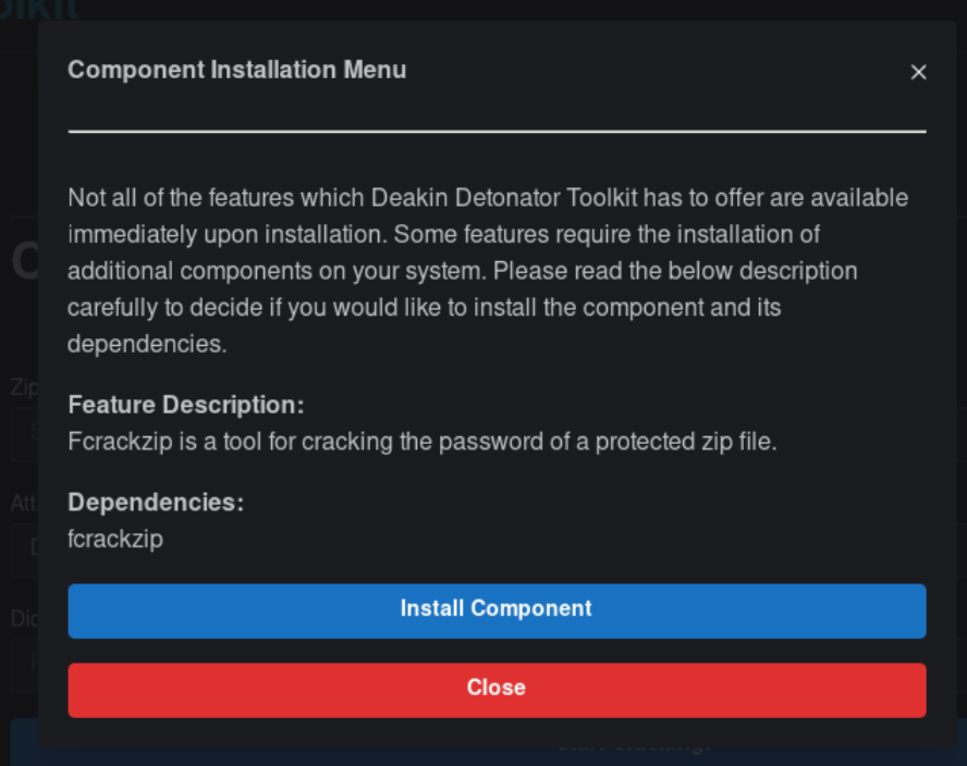

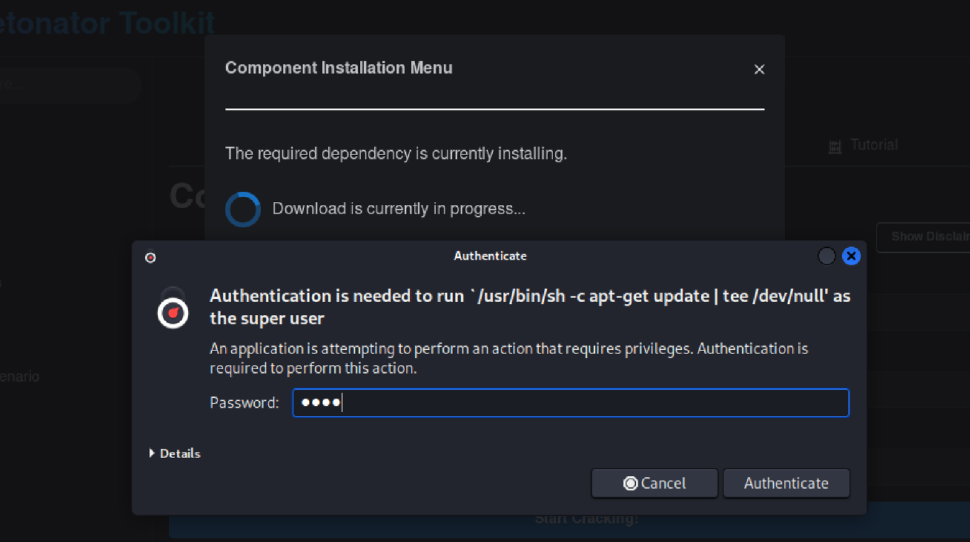

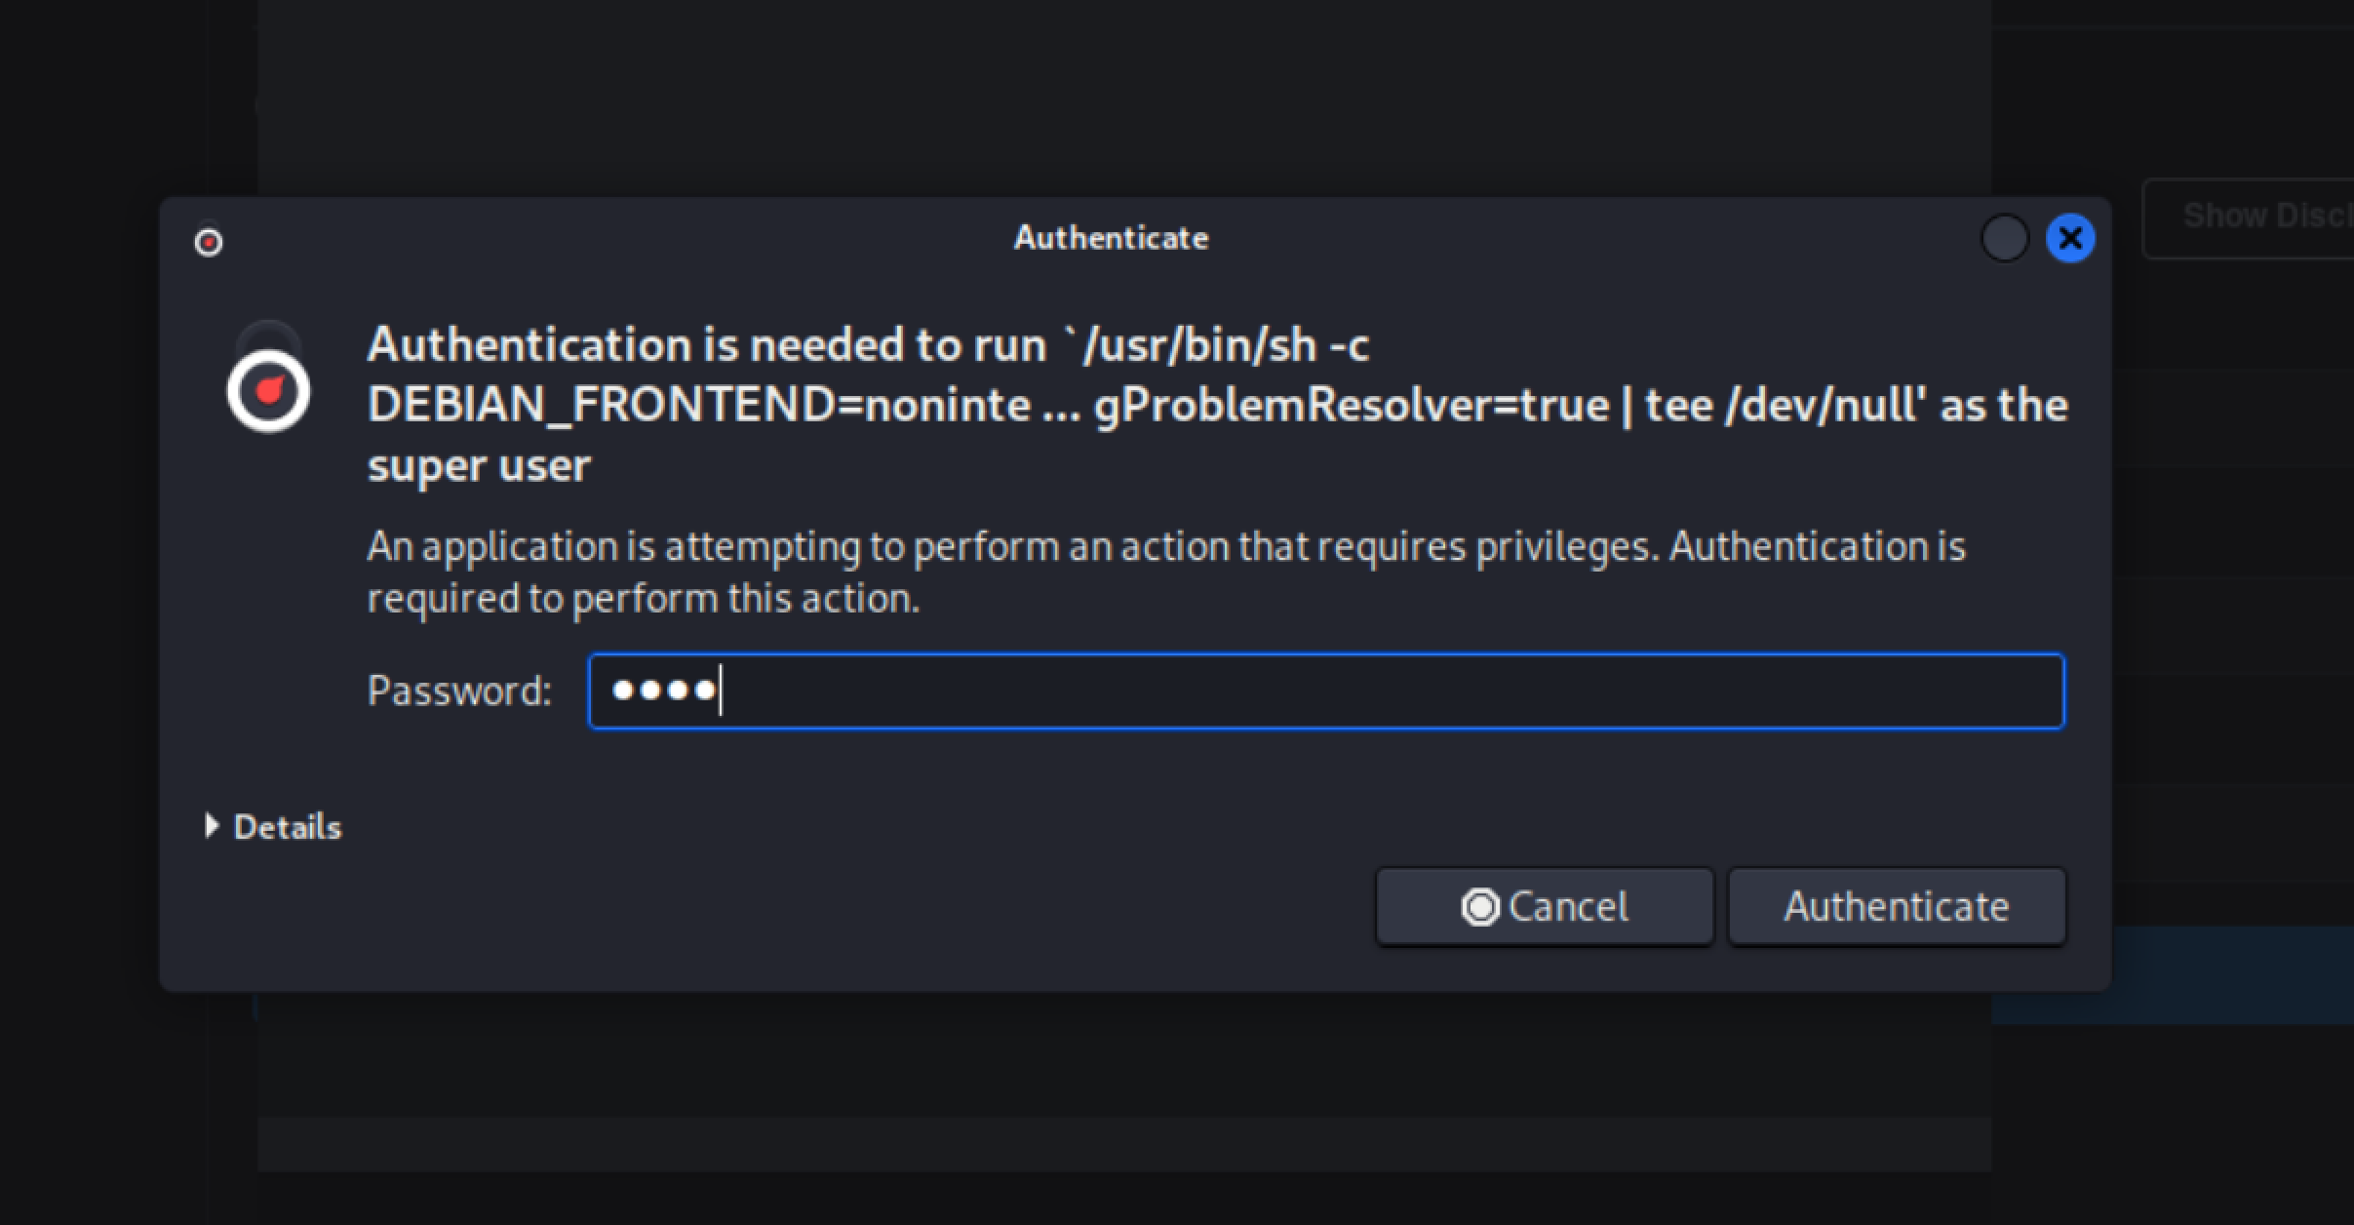

Step 4: Configure the Tool
The tool interface contains configuration fields under the Configuration tab. You can use either of the following options:
Option A: Dictionary Attack
- Zip File: Path to the password-protected .zip file
- Attack Method: Choose “Dictionary”
- Dictionary: Path to the dictionary .txt file that contains possible passwords
Click Start Cracking! to begin.
You may receive a superuser authentication prompt during cracking. Enter your password (e.g., KALI) to allow the scan to proceed.
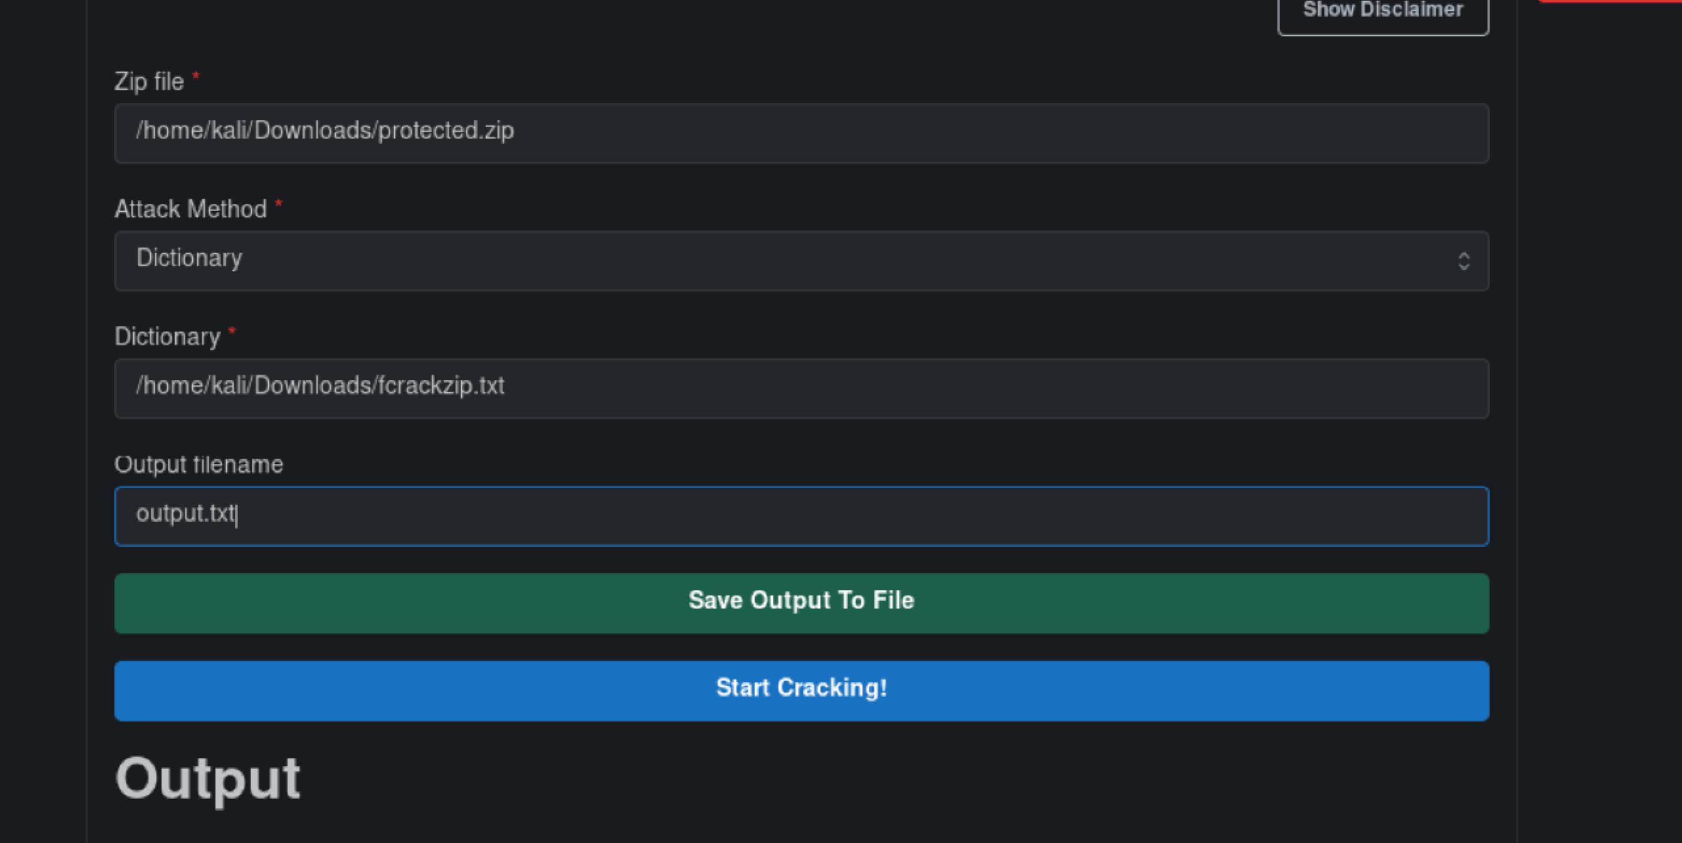
Option B: Brute Force Attack
- Zip File: Path to the password-protected .zip file
- Attack Method: Choose “BruteForce”
- Charset List: Choose character types (e.g., lowercase, numeric)
- Min Length and Max Length: Set the length range of the passwords to try (e.g., 1 to 7)
- Optional: Tick “Show Cracked Password” to see the result displayed
Click Start Cracking! to begin.

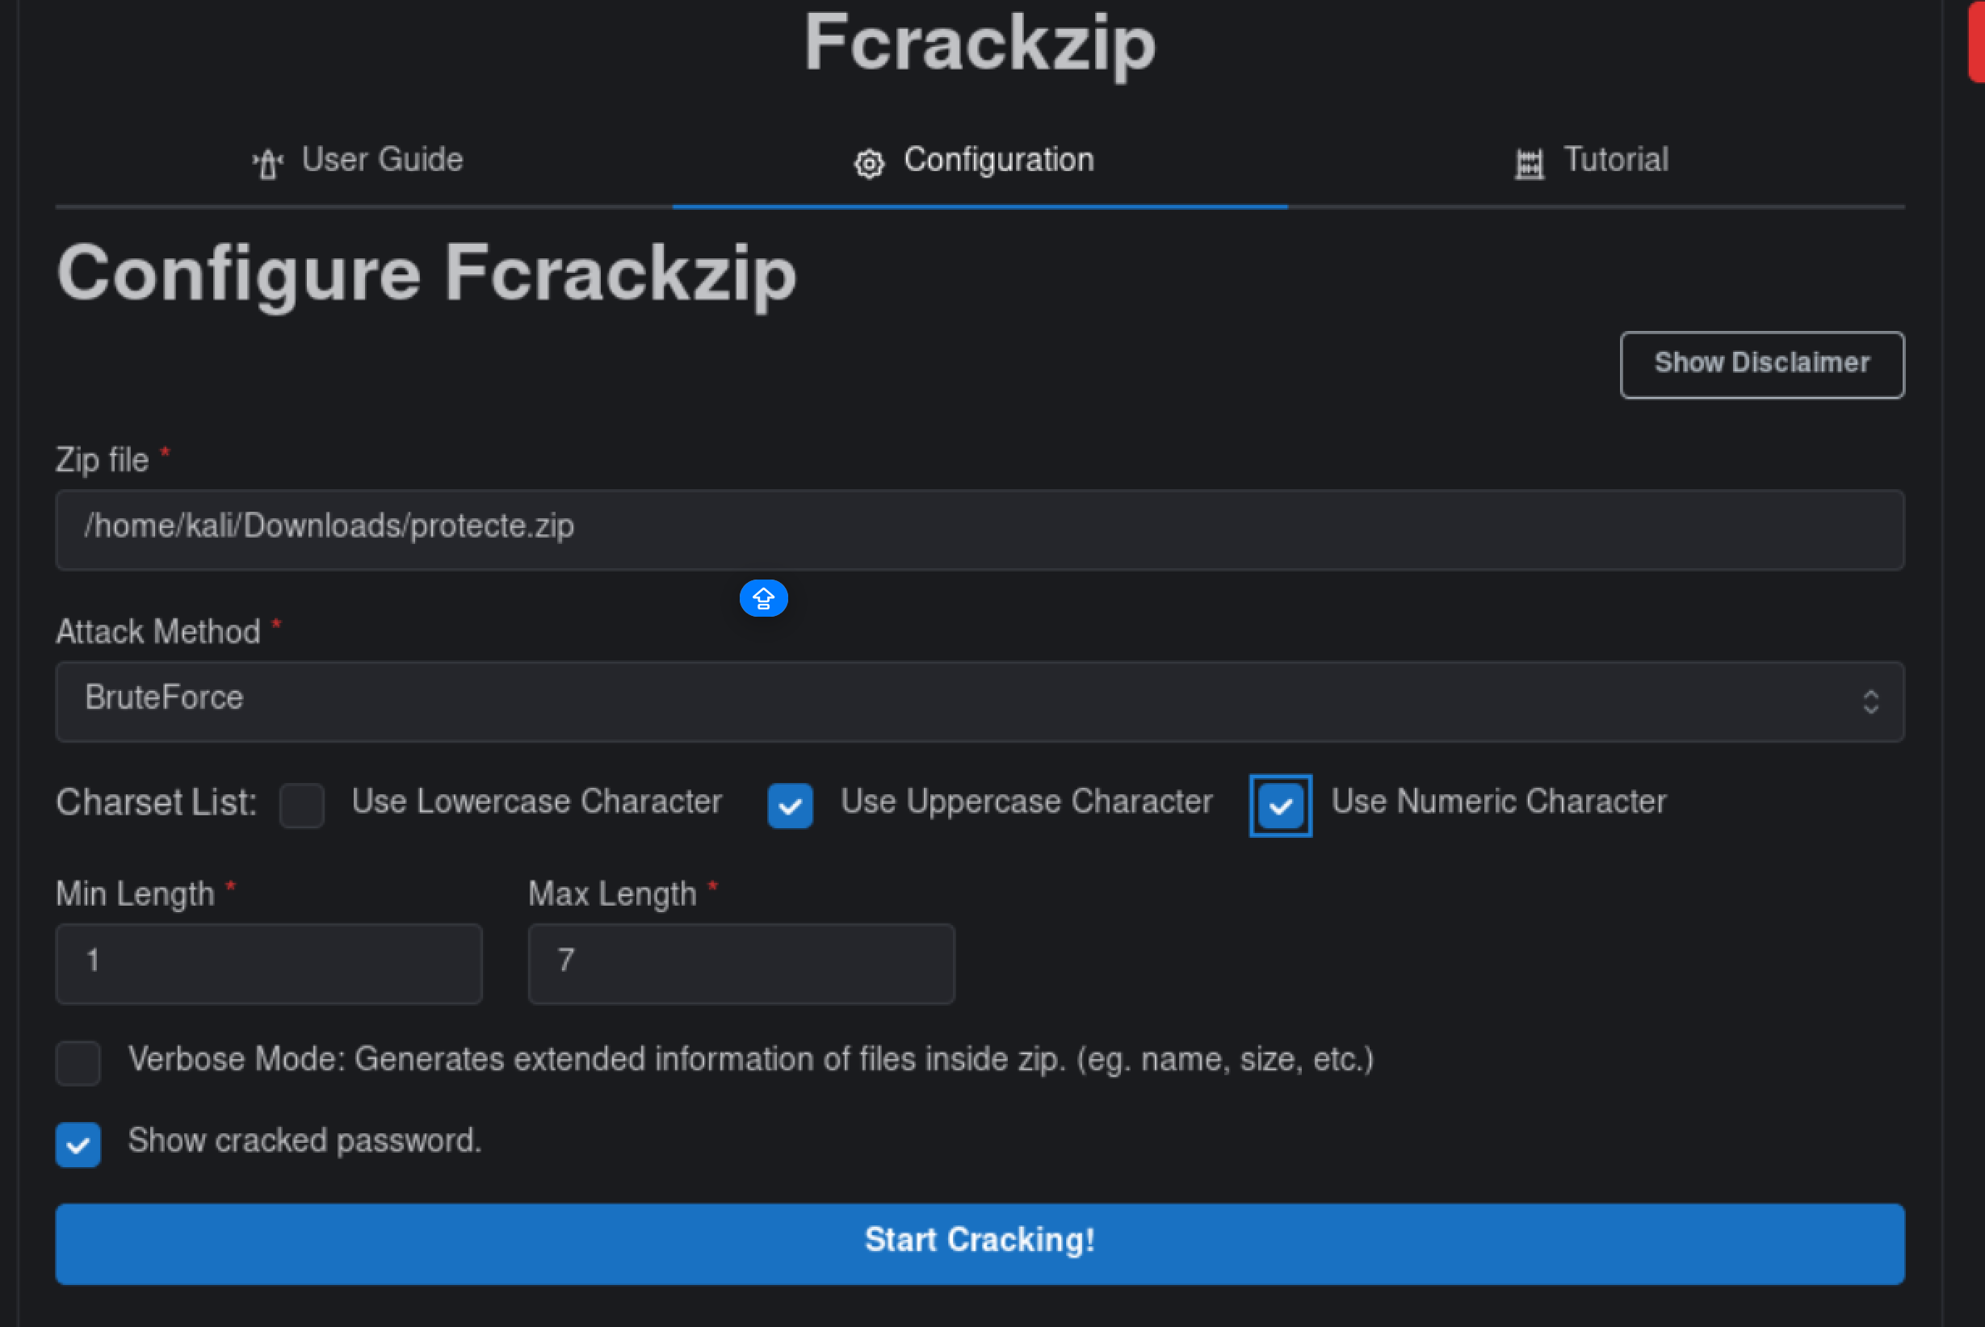

Step 5: Viewing Output & Interpretation
In this guide, we used the Dictionary Attack method to perform the password cracking process. The tool attempted passwords from the selected wordlist file against the ZIP archive.
As soon as the cracking process starts, the tool will try different passwords from the dictionary file or generated based on the selected charset.
- If the correct password is found, it will show:
- PASSWORD FOUND!!!!: pw == yourpassword
These details confirm the ZIP file has been cracked successfully.

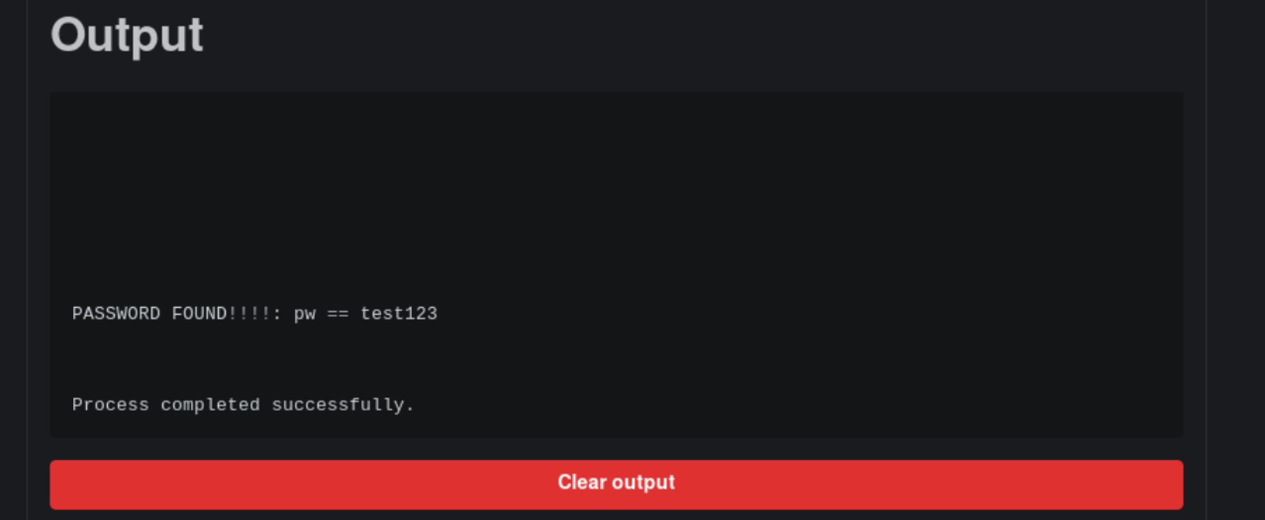

Saving, Clearing, and Resetting Output
Once the cracking is complete:
- Click Save Output To File, type a filename (e.g., output.txt), and save.
- Click Clear Output to remove results from the current session.

Troubleshooting & Visuals
Common Issues & Fixes:
- File Not Found: Double-check the file path entered in the GUI.
- No Output: Make sure the dictionary file contains the correct password.
- Permission Denied: Run the scan with superuser privileges.

